What Is My Hat Made Of?

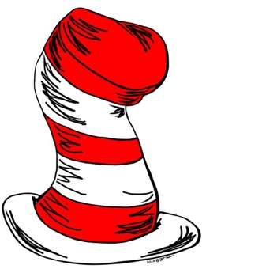

[This Photo](http://2hello2.deviantart.com/art/Cat-Hat-185761634) by Unknown Author is licensed under [CC BY-NC-ND](https://creativecommons.org/licenses/by-nc-nd/3.0/)



Evidencing the process

Tapestry, class website page, Facebook, enquiry books

Celebrating the challenge:

A fashion show of hats for our families to attend.

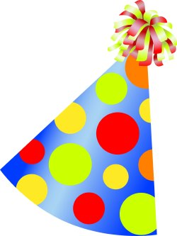

[This Photo](http://www.dailyclipart.net/clipart/birthday-party-hat-clip-art/) by Unknown Author is licensed under [CC BY-ND](https://creativecommons.org/licenses/by-nd/3.0/)

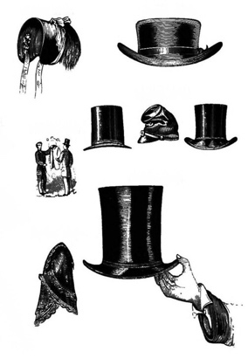

[This Photo](http://flickr.com/photos/double-m2/4638435978) by Unknown Author is licensed under [CC BY](https://creativecommons.org/licenses/by/3.0/)

Immersion: knowledge

Children investigate what different hats are made of and what they are for. They start to understand why the hats are made of different materials and can describe them.

**Milestone**

Learners are able to distinguish an object and the material from which it is made. They are able to identify a range of common materials and describe their properties.

Through looking at hats children start to learn about construction and what properties a hat will need to make it wearable. They learn how to make basic shapes needed for a hat and techniques for ensuring they will be wearable.

**Milestone**

Learners understand how to make structures stronger, stiffer and more stable.

Practice: skills

Children will decide the purpose for making their hat and design it accordingly using their knowledge and understanding of materials and making techniques. They will construct their designs and amend them as they work if needed.

**Milestone**

Learners design purposeful and functional hats. They are able to use the skills they have learnt to make a hat for our challenge.

Immersion: skills

Using the context of hats and what they are used for, children will test them to see if they are waterproof, warm, cool etc (children will determine their interests and we will test these).

**Milestone**

Learners are able test materials to compare their physical properties making careful observations as they work.

Children will make their own simple hats using a range of taught techniques.

**Milestone**

Learners are able to use a range of tools to cut, shape, join and finish their hats.

Practice: knowledge

Children use their knowledge of materials and making techniques to choose appropriately in order to make their design. They test their ideas and can change them if they do not work.

**Milestone**

Leaners are able to select appropriate materials to make a hat for our challenge.

Engage

Launch with hats!

Have as many different hats as possible in the classroom for children to explore and try on. Take a photo of each child in their favourite hat!

The Challenge

To make a hat to protect us from a chosen weather element…