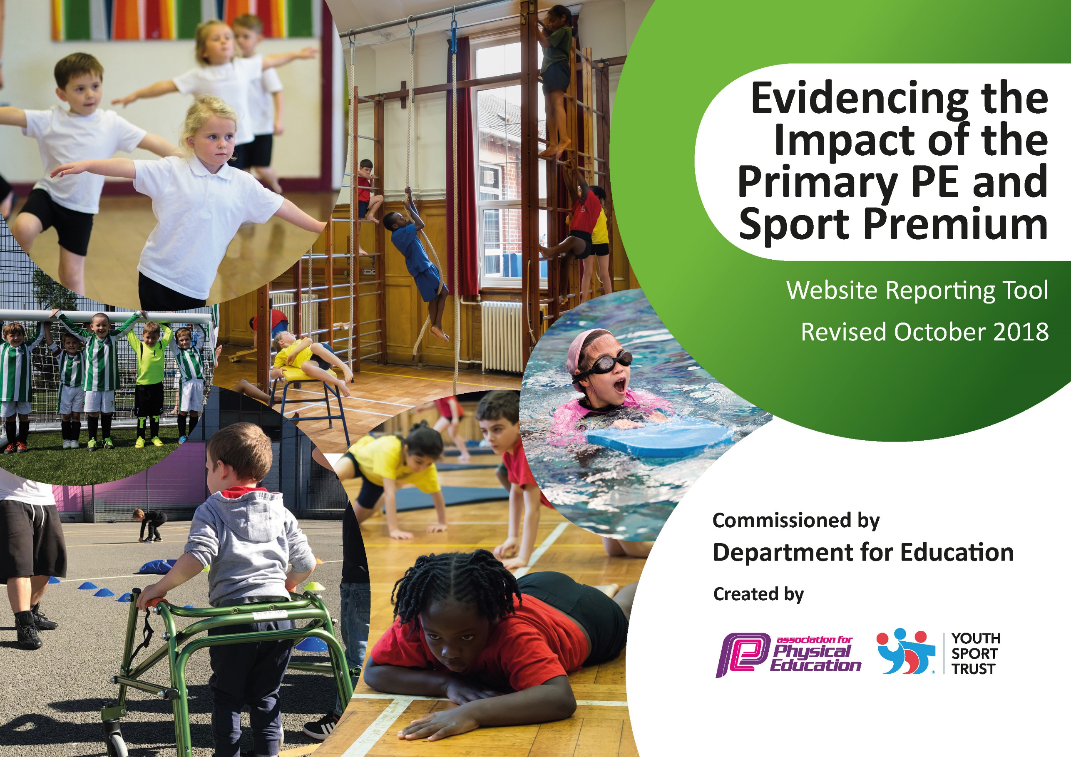
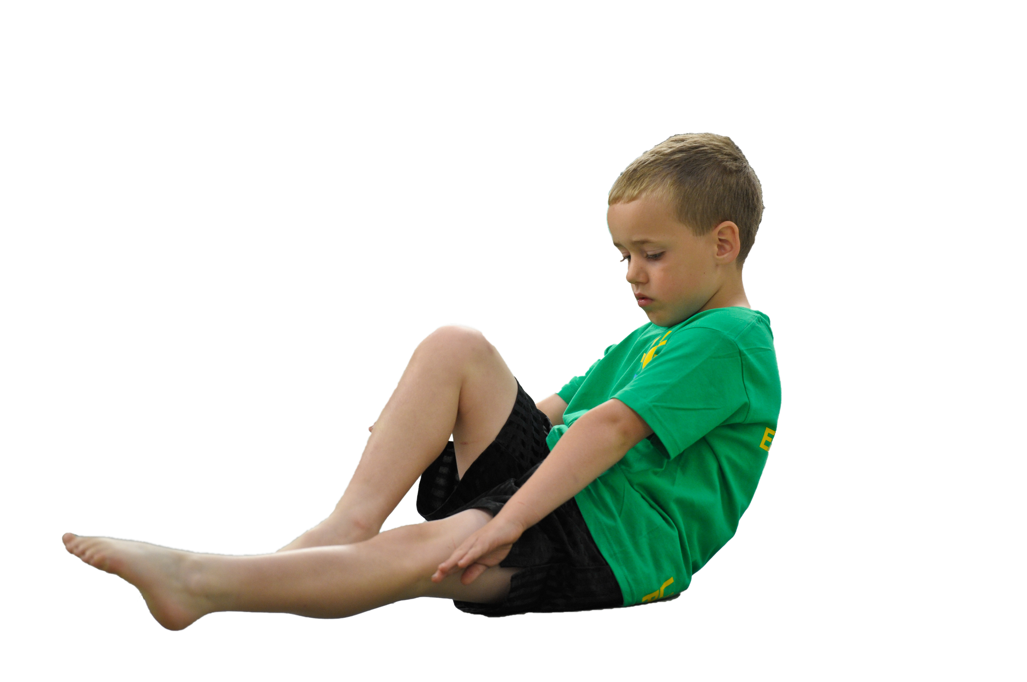
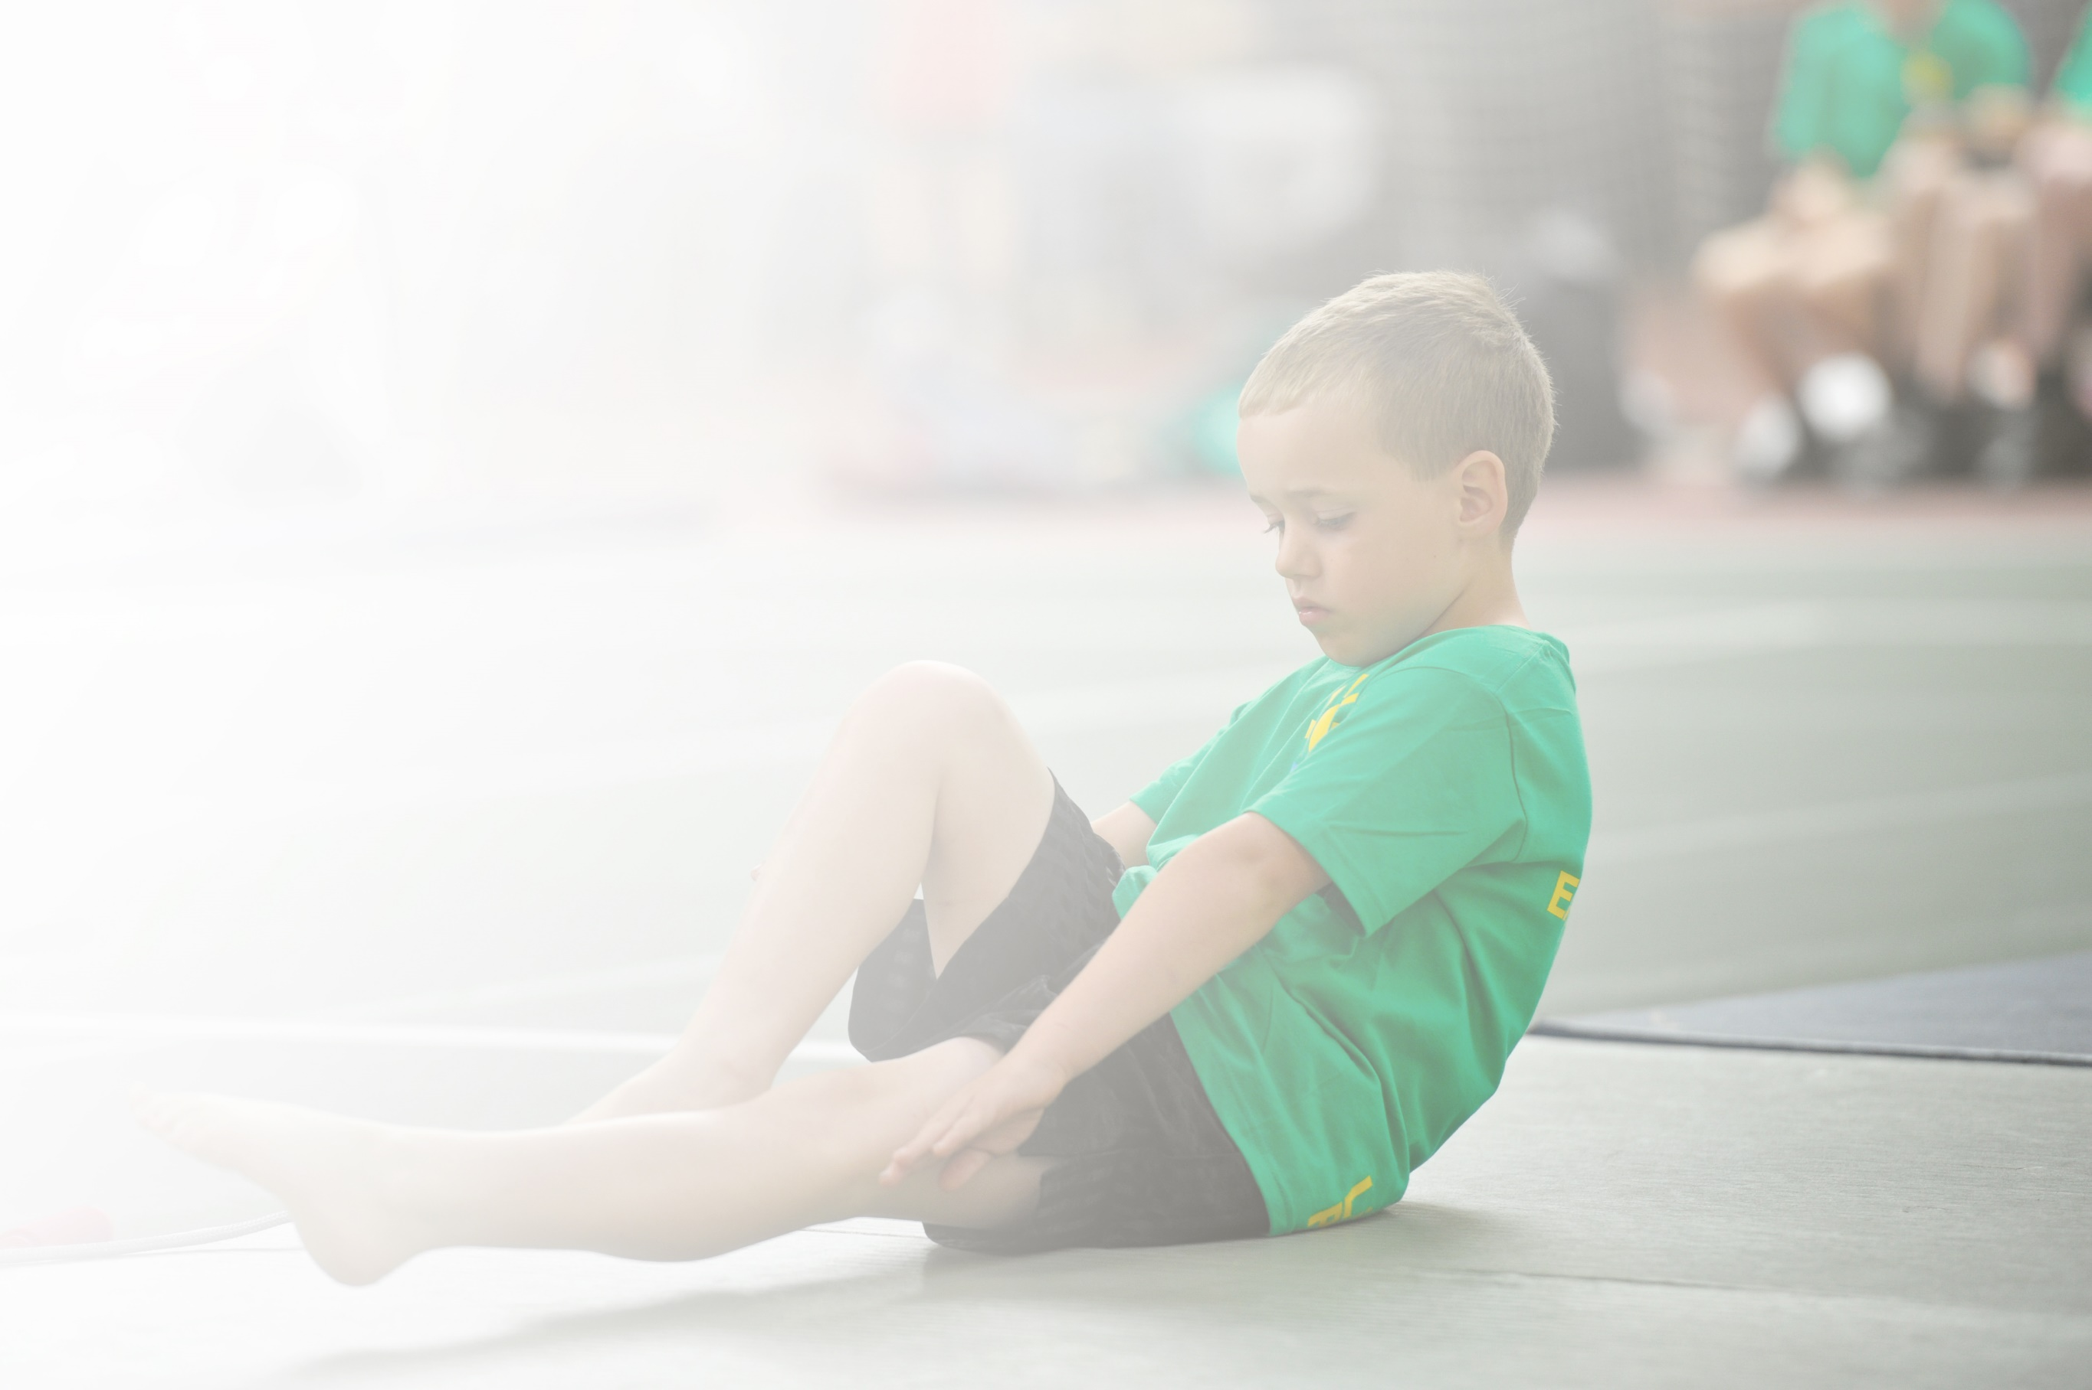
Schools must use the funding to make additional and sustainable improvements to the quality of Physical Education, Sport and Physical Activity (PESPA) they offer. This means that you should use the Primary PE and Sport Premium to:

- Develop or add to the PESPA activities that your school already offer
- Build capacity and capability within the school to ensure that improvements made now will benefit pupils joining the school in future years

Please visit gov.uk for the revised DfE guidance including the 5 key indicators across which schools should demonstrate an improvement. This document will help you to review your provision and to report
your spend. DfE encourages schools to use this template as an effective way of meeting the reporting requirements of the Primary PE and Sport Premium.

We recommend you start by reflecting on the impact of current provision and reviewing the previous
spend. Under the Ofsted Schools Inspection Framework, inspectors will assess how effectively leaders use the Primary PE and Sport Premium and measure its impact on outcomes for pupils, and how effectively governors hold them to account for this.

Schools are required to publish details of how they spend this funding as well as on the impact it has on pupils’ PE and sport participation and attainment by the end of the summer term or by 31 July 2019 at the
latest.
We recommend regularly updating the table and publishing it
on your website throughout the year, as evidence of your
ongoing review into how you are using the money to
secure maximum, sustainable impact. To see an
example of how to complete the table please
click HERE.

Support for review and reflection - considering the 5 key indicators from DfE, what development needs are a priority for your setting and your students now and why? Use the space below to reflect on previous spend, identify current need and priorities for the future.

Key achievements to date: | Areas for further improvement and baseline evidence of need:
Redbrook Primary School  - Improved quality of delivery  - Increased bredth of PE curriculum  - Increased confidence of teachers to plan/teach/assess PE lessons  St Briavels Primary School  - Boosted swimming outcomes  - Increased physical activity levels of all pupils  - Increased engagement in school games | Redbrook Primary School  - Physical activity levels of pupils  - Sustainable spend of Sports Premium – coaching PE lead for future  - Increase inter school competition  St Briavels Primary school  - Physical activity levels of pupils  - Sustainable spend of Sports Premium – coaching PE lead for future  - Consistent planning reference

Meeting national curriculum requirements for swimming and water safety | Please complete all of the below:
What percentage of your current Year 6 cohort swim competently, confidently and proficiently over a distance of at least 25 metres?  N.B. Even though your children may swim in another year please report on their attainment on leaving  primary school. | Redbrook 100% - 2 pupils (1 with an inner ear issue stopping him from putting his head under the water)  St Briavels 90%
What percentage of your current Year 6 cohort use a range of strokes effectively [for example, front crawl, backstroke and breaststroke]? | Redbrook 50% - 1 pupil  St Briavels 90%
What percentage of your current Year 6 cohort perform safe self-rescue in different water-based situations? | Redbrook 50% - 1 pupil  St Briavels 90%
Schools can choose to use the Primary PE and Sport Premium to provide additional provision for swimming but this must be for activity over and above the national curriculum requirements. Have you used it in this way? | Redbrook - No  St Briavels - No

Action Plan and Budget Tracking
Capture your intended annual spend against the 5 key indicators. Clarify the success criteria and evidence of impact that you intend to measure to evaluate for students today and for the future.

Academic Year: 2018/19 | Total fund allocated: £  Redbrook £16,270  St Briavels £17,160  Total Federation spend including carry forward from last year.  £37,683.14 | Date Updated:  September 2018 - Carry forward from 2017/18:  Redbrook: £2163.14 (From SP Report 17/18)  St Briavels: £2,150 (From SP Report 2017/18)
Key indicator 1: The engagement of all pupils in regular physical activity – Chief Medical Officer guidelines recommend that primary school children undertake at least 30 minutes of physical activity a day in school |  |  |  | Percentage of total allocation:
 |  |  |  | %
School focus with clarity on intended impact on pupils: | Actions to achieve: | Funding allocated: | Evidence and impact: | Sustainability and suggested next steps:
Across both schools, implement the following interventions:  Positive Playtime Practice – Introducing the 5 Ways to wellbeing at break time and lunch time – one strand focuses on Physical activity levels.  Play/Wellbeing Leaders training for Y5/6  Can we increase the physical activity levels of all pupils and some staff by bringing in a ‘daily mile’ style practice?  Teachers to be sent on CPD linked to active classrooms  Raising the profile of Physical Activity – Pupils, Parents, Teachers & Govs – Putting an importance on this behavior  Increase physical development opportunities for Rec/KS1 | Book PPP in for Sept/Oct  Audit of children who are physically active, or not, during these periods and the impact the practice has had on them. Can we report by the end  of the year on who has increased their PA levels?  Book in training for this to be delivered. Train up the Y5/6 leaders to support the offering of more physically active opportunities.  Start up a daily walk/jog/run in the playground - across the federation for both pupils and staff. Tis will need to be done on at least 3 days a week to gain the benefit (DM guidance).  Link into local Sports Partnership to access this CPD  CP – to deliver after school staff meeting on active classrooms Summer Term 2019  Newsletter for Autumn term 2, Spring Term 2 and Summer Term 2.  Set up sessions for these children to attend the soft play at Monmouth Leisure Centre – once started, include Maths tasks so that the children are learning while being active | Funded by Active Forest of Dean  Additional resources to support this practice £500 - £250 per school  £350 plus Vat  (St Bs)  £495 plus Vat (RB)  Free  £30/£40 per session  Per school  (RB x 5 sessions)  £160  (St B’s x 3 sessions)  £160  RB plus bus  £100 x 3  £300 | Both schools now have sets of data sharing their current wellbeing behaviours and an action plan for break and lunchtimes of how they will increase those behaviours, including physical activity.  (This needs to be spent at RB)  Have started the daily mile across the federation. Both staff and pupils complete in.  Photographs taken and shared in the Autumn term newsletter – quotes taken from pupils – impact on their body and mind  We have attended 2 CPD sessions to date. One on active Schools and the other on achieving School Sport Status for 2019/20.  Newletter sent our in at the end of the Autumn term  Autumn Term newsletter sent out to parents Dec ’18 sharing curriculum PE, after school sessions, visiting tutors, daily mile and school games events.  Also includes quotes from children, teachers and parents.  Our playground has no equipment that develops their strength – especially their gross motor development. The soft play sessions make the children really work physically for at least | Staff trained alongside pupils – can then be delivered by school staff again in the future.  Resources to be bought through SP funding.  Pupils have significantly increased their daily physical activity levels. All staff and pupils now run a mile at least 3 days a week across both schools.  We have used this intervention as evidence to achieve Healthy Schools Status in Gloucestershire this year.  Next year’s sports premium report has clear outcomes mapped against the objectives that will achieve the School Sports Status.  Parents commented on the quality of the provision across both schools and said their pupils were loving PE this year.  Pupils in Reception & KS1 in Redbrook and then Rec in St Briavels, all increased their weekly physical activity levels, but also increased their time focusing on fine and gross motor development.
£1735
Key indicator 2: The profile of PESSPA being raised across the school as a tool for whole school improvement |  |  |  | Percentage of total allocation:
 |  |  |  | %
School focus with clarity on intended impact on pupils: | Actions to achieve: | Funding allocated: | Evidence and impact: | Sustainability and suggested next steps:
Specialist PE Leader to come in and set up sustainable outcomes from the spend this year.  PE kits to be bought for all pupils at Redbrook - Tesco  WFF Competitive Sports kit to be ordered  PE hoodies to be bought for Teachers to use for PE delivery and out of school events  Become a member of the National PE Association – AfPE – as a school  Work towards gaining the Gloucestershire Healthy Schools Status for both schools. Auditing current outcomes and setting up 2 interventions as a result of the audit.  Once accomplished, move onto working towards the Gloucestershire Mental Health Champion Status across the Federation. | Coach TA to lead PE from 2019/20 onwards  Set up Insight to track curriculum outcomes and PA outcomes  CPD to be delivered through PE but referred back to other curriculum areas x 3 a year  Every child feeling and looking ready to participate in PE lessons  Contact a few suppliers and ask for quotes  Every Teacher feeling and looking ready to deliver PE lessons across the Federation  Can we go for the AfPE quality mark for PE outcomes?  CP to lead this audit and intervention creating process.  CP to lead this. | £6,000  Autumn Term  £6,000  Spring Term  £6,000  Summer Term  £200 in total  £450  £450 | School PE and Healthy Schools Specialist brought in to work with SLT to develop a sustainable PE curriculum, after school club structure and school games participation.  To date Dec ’18, we now have:  - A broader PE curriculum  - More visitors in delivering who are then signposting to local clubs  - A daily mile for staff and children  - Higher quality PE lesson delivery  - More accurate assessment  - Staff with higher confidence of teaching and assessing  2 WFF based tournaments have been arranged for the Spring and Summer Terms – Hi 5 Netball and Rounders – 2 x Other local schools have asked to take part  End of Key stage assessment snapshots are now taking place on insight  None delivered to date  Example top has arrived – need to size up all children and add shorts, then order - RB  Black sports top – long sleeved/Shorts/long socks  WFF badge and Physical Education Staff on the back – Black  2 x audits completed to see the strengths and next steps of the school – Dec ‘18  2 x interventions to be written up for both schools – both to include the daily mile and 1 other  Evidence from the Healthy Schools Audit will go in as evidence for this status. | PE leader set up the following to be used by member of staff in charge of PE for 2019/20  Risk assessments  Curriculum – Broad and balanced  Healthy Schools Evidence  Assessment templates  Outside provider links  Community links  Swimming provision  After School Club provision  Ongoing Leadership  Links to school sport cluster  Pupils attended School Sports Archery this year in their new kits and parents commented on how smart they looked. The pupils felt better prepared as a result of earing their new kit.  All teachers across the Federation now wear their PE hoodies while teaching PE – this has raised the profile of PE and the need to be dressed ready to learn in PE  Evidence presented for both Schools across the Federation – Healthy Schools Status achieved for both Schools for 3 years – 2019/2022  Analysis of staff needs completed and staff inset set up to gauge staff wellbeing behaviours – Sept 2019
£19,100

Key indicator 3: Increased confidence, knowledge and skills of all staff in teaching PE and sport |  |  |  | Percentage of total allocation:
 |  |  |  | %
School focus with clarity on intended  impact on pupils: | Actions to achieve: | Funding  allocated: | Evidence and impact: | Sustainability and suggested  next steps:
Across the Federation, set up a consistent planning reference point – Lancashire PE Framework to be trialled this year – CP to bring – then it can be purchased if successful?  Staff to access/observe/team teach high quality PE lessons. | Use Lancashire planning to lead delivery – keep in central place for reference – not digital just hard copy  CP to lead PE delivery for a class a term to offer observation and team teach opportunities.  From Spring Term 2019, an increased amount of strategic outside delivery will take place to offer teachers the chance to observe, gain planning schemes and build confidence to assess a wider curriculum offer.  Jack Fowler – now Prostars  Redbrook – Fridays for Spring Term  Lesson to include:  - Yoga  - Fitness  - Archery  Didi Rugby – Suzanne Applby-Jones  Redbrook – Taster session 3.12.1  St Briavels – Reception and Year 3/4 delivery for 6 sessions Spring Term  With the introduction of the wider curriculum, equipment may need to be purchased to enable the staff to then deliver themselves. | £1,000  £120  £720 | Lancashire PE scheme available in the staff room for future reference – needs to be shared with all staff  At the start of the year staff noted that they didn’t feel confident finding appropriate planning, delivering and then assessing some units of PE. Each member of staff highlighted an area they would like to work on. These areas were then team taught during Autumn Term and the staff as a result, felt more confident when looking for planning, as they now understood in more detail the levels in which their pupils were working so the planning they found, they were then able to annotate and develop.  They are now using insight to track outcomes and also to plan from – for target pupils.  Teachers were consulted as to what additional delivery they would like to open up broader opportunities for the pupils next term.  As a result of teacher and pupils voice, the following has been booked in across the federation.  Didi rugby brought in to deliver a taster session at RB  Didi rugby brought in to deliver a 6 week unit of work at St B’s with Rec class | All staff now have access to the planning resources across the Federation.  All staff are now using the resource.  All staff have now team taught units of PE that they highlighted as an area of improvement.  RB staff have seen all areas of the curriculum taught.  St B’s wanted to observe competitive sports – especially in KS2  During the Spring Term we brought in:  Archery, yoga and tag rugby across both schools – Teachers now feel confident to deliver both next year.  The Redbrook pupils loved the Didi rugby taster sessions – photos available via the school newsletter – the pupils asked for club options in the local area so they were also added to the website 3.12.18
£1,840
Key indicator 4: Broader experience of a range of sports and activities offered to all pupils |  |  |  | Percentage of total allocation:
 |  |  |  | %
School focus with clarity on intended  impact on pupils: | Actions to achieve: | Funding  allocated: | Evidence and impact: | Sustainability and suggested  next steps:
Additional achievements:  Use the sport funding to offer wider opportunities through outside providers, e.g.  Redbrook – More equipment needed to support a broader PE delivery  - Rounders set  2 x Staff members to be trained as Forest Schools Leaders – increasing outdoor physical activity opportunities for all pupils  Develop Forest School Area – More engaging for pupils | Gillian Traverse to be brought into RB to set up an outdoor learning day  Basic equipment to be purchased to enable the traditional PE units to be delivered  Book Forest School Training for 2 members of staff | £500  £2,000  £1,000 | Gill came in at the end of Summer Term to work with Rec/KS1 at RB  To be carried over to 2019/20  2 x staff trained up at Forest School Leaders | The pupils had a fantastic day and staff got plenty of ideas of how to run their own next year.  Forest Schools sessions are now run every week for both schools by the 2 leaders.
£3,500
Key indicator 5: Increased participation in competitive sport |  |  |  | Percentage of total allocation:
 |  |  |  | %
School focus with clarity on intended  impact on pupils: | Actions to achieve: | Funding  allocated: | Evidence and impact: | Sustainability and suggested  next steps:
Offer informal competitions for pupils to take part in before going to School Games events.  Take part in School Games events  Set up interschool events – Cross Country, Tag Rugby, Hi 5 Netball, Football & Rounders.  Can we achieve School Games Bronze mark across the Federation?  Increase opportunities for school-based competition | Link up with 2/3 local schools  Set up a competition group  Host either at St B’s or at 5Acres High School - we did this last year for Redbrook (Hi 5 Netball)  Book into Forest School Games for 2018/19  Book into curriculum time for Spring/Summer Term  Start up Y.S.T. membership if needed? Not needed  Set up pre-competition and School Games participation | £20  Biscuits/Squash/  Free | All set up – 2 schools booked in for Hi 5 Netball and Rounders.  Both schools have taken part in Cross Country and Quick Sticks hockey. All pupils loved the experience! Photos and quotes on newsletter Autumn Term 2018.  Both schools took part in intra school cross country.  Redbrook have had a KS2 competitive ‘End ball’ afternoon.  Both Schools are signed up to the Sainsbury’s School Games Mark website  Dec ’18 – both schools have 2 games participation marks – we are aiming for 6  Both schools within the federation took part in an intra school cross country day – photos on the Auyumn Term Newsletter | Pupils played in some competitions and enjoyed the experience.  The pupils from both schools took part on Cross Country, Hockey and Archery.  Both schools had a cross country competitive race.  School now has clear targets to be able to achieve this next academic year.
£20

Planned WFF spend:

Objective 1 £1,735
Objective 2 £19,100
Objective 3 £1,840
Objective 4 £3,500
Objective 5 £20

Money available: £37,683.14
Spend: £26,195.00

Carry over: £11,488.14

