Case Study 1

The Wye Forest Federation

Consisting of:
St Briavels Parochial C of E School
Redbrook C of E Primary School

Understanding the Issue being tackled
The Wye Forest Federation is made up of two schools, one in the heart of the Forest of Dean and the other on the welsh border, near Monmouthshire.

At the beginning of the 2017/18 academic year both Schools found themselves advertising for a leader of Physical Education. This came about as their previous PE lead had left to join another school.

That member of staff left with many years of expertise and due to the very quick process which takes one member of staff to another school, the School found itself with staff who felt anxious about delivering certain units within the PE curriculum, but more importantly they found the health and safety management involved in PE needing attention.

At the start of the 18/19 year the School decided to run a whole federation audit which looked at current assessment, planning and delivery models from EYFS to Year 6. This put the Senior Leadership Team in a good place to set up the Sports Premium Spend for that year into target areas that fell into the 5 key DfE outcome areas.

At the end of September, 2018, the school employed a PE teacher with years of experience to work with all staff to create a model for PE, that when he left, would mean that the areas of PE that were highlighted in the Schools audit would be addressed and then set up to be managed by the school when he left in 2019/20.

It was also highlighted by the Senior Leadership Team that as a result of the improvements in practice over the year, they would like to present their newly acquired impact evidence to head towards their Healthy Schools Status, and alongside this try to work with wider partners within Gloucestershire to try to boost the physical activity levels of their pupils.

What actions were taken? Role of local and national partners (GHLL/AG)
The school decided to pool their Sports Premium money to be able to employ a specialist PE teacher. This specialist teacher also advised School leaders on how to spend, report and assess the impact of the spend.

The teacher employed by the school put the following practice in place:

- Training for Governors, for them to be able to monitor the schools Sports Premium spend by SLT
- Staff training – Making sure all staff understand what the Sports Premium is to be used for and how the impact will be monitored
- Risk assessment framework we created for all staff to access – these linked to all units within the curriculum, including offsite visits and swimming
- Taught team teach lesson across the Federation, once he had gauged where the staff needed that assessment/planning/delivery support.
- Engagement with wider partners, GHLL (Gloucestershire Healthy Living and Learning, Active Gloucestershire, Chance to Shine cricket and Progressive Sports.
- Created an up to date curriculum with greater breadth of experience
- Offered a wider range of after school sessions
- Increased the amount of school games attended by both schools
- Made the sporting uniform consistent across the schools for both the pupils and the staff
- Ensured staff CPD became available within the local Sports Partnership
- Made sure the website shared the actual outcomes of PE for all to see
- Set up focus days for staff and pupils to focus on physical activity and wellbeing
- Created a photographic newsletter for parents as a celebration of outcomes and to raise the profile of PE across the Federation

Evidence of Impact
Objective 1:
The introduction of the Daily Mile had a huge impact on the physical activity levels of the pupils and staff across both schools. Redbrook School also incorporated English and Maths activities into their Daily Mile after doing it for a term.

The School also brought in a training rovider that helped the pupils understanding more about the ‘5 Ways to Wellbeing’ and where physical activity sat in amongst the 4 other focus areas. The pupils then planned more activities to boost physical activity at break and lunch times which then also boosted the pupils behaviors in the other 4 areas.

Objective 2:
The school’s newsletter which presented so may sporting/teaching successes, along with the introduction of a staff PE kit had a big impact on the way staff looked at PE within the whole curriculum. Parents commented on the enjoyment they had reading the newsletter and some then saw the school making it more of a priority, just because of the increase exposure it was being given.

The pupils were also bought a sports kit for the first time, across the federation. This made them feel very special when taking part in any school games. For some of them this kick-started better attitudes towards work in other areas of the curriculum.

Objective 3:
The team teaching set up had a positive impact on the staff who now say they are happy to deliver target units this year on their own with increased confidence to plan (Differentiate), deliver and then assess.

Objective 4:
With the introduction of archery, cross country, yoga, fit2learn, wellbeing leaders and other curriculum opportunities, the pupils felt that their curriculum had now been brought to life, and that they enjoyed PE more. The School council had been consulted on the range of new activities that could be brought in and they took it too their peers who choose the activities stated above.

Objective 5:
Across both schools, School Games participation rose from 3 events the previous year to 6 for both school in 18/19.

Not only did the school take part in more school games events, more staff experienced the events too. This was something the school needed to set up, so that when the PE teacher left, others would feel confident taking their classes to school games events. The Federation now has a wider bank of staff that are confident taking pupils to events.

Direct Quotes from the School
Miss Natalie Taylor
PE Coordinator 2019/20
and teacher linked with specialist teacher in 2017/18
As a Federation, through the employment of a specialist teacher to work alongside us last year, we feel that this year we are now more aware of the role of PE and School sports in our schools and are continuing to take an active role in ensuring all children are fitter and healthier.
With more school games attended last year, children are able to feel part of a much wider community.
Over the next year, we intend to build on the successes and structures created last year and continue to make sport, and physical activity, a priority in everyone’s lives.

How National or Local partners have worked together to support the school
Active Gloucestershire supported both pupils and teachers across the federation to set up their Daily Mile. They also supported the lead PE teacher to focus sustained improvements at target areas and acted as a sounding board throughout the year.

Gloucestershire Healthy Living and Learning the County Council Healthy Schools Team supported the PE leader and other Senior Leaders during the year to collate all PSHE/PE impact data to complete a Healthy Schools audit and write up 2 target interventions – Both schools achieved separate Healthy Schools Awards as a result in July 2019.

Ofsted Inspection comments – Redbrook - July 2019
Personal Development and Welfare
Teachers follow a structured programme to develop pupils’ personal, social and health awareness which takes into account pupils’ views. Pupils understand how to eat healthily and participate in the ‘daily mile’ which stresses the importance of physical activity. Staff reinforce mental well-being through focused days that centre on this issue.
Effective leadership and Management
The physical education (PE) and sport premium has been used effectively and diligently. This has been successful in increasing pupils’ enthusiasm to take part in activities, either recreationally in the playground or in competitive situations.
Leaders have appointed additional staff who have the skill and the passion to promote this area of pupils’ learning.
Such expertise is being used to train staff to evaluate the impact of activities on the development of pupils’ skills.

Additional evidence – photographic
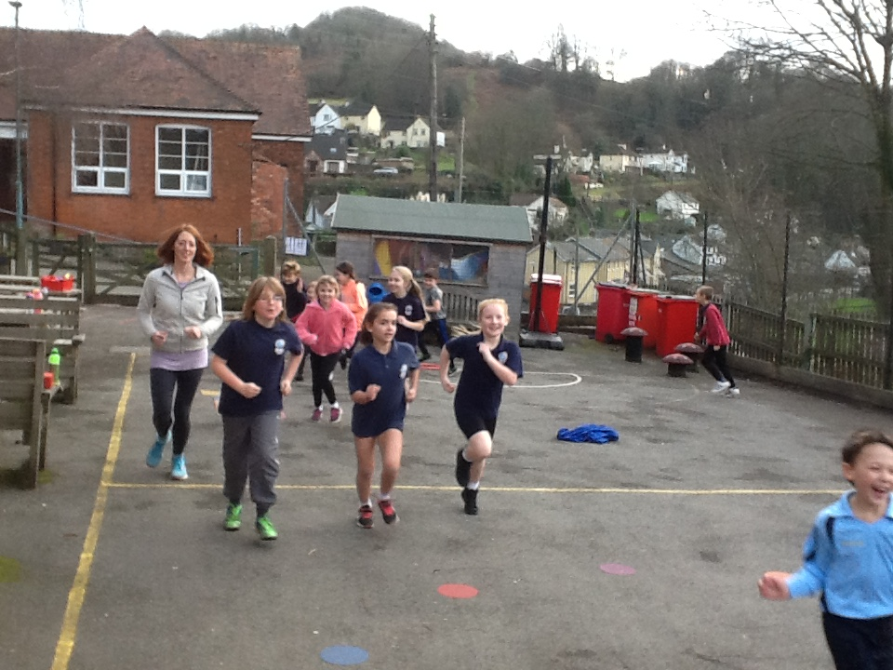  Supporting Redbrook Year 3/4/5/6 & teacher  Setting up a ‘Daily Mile’. | 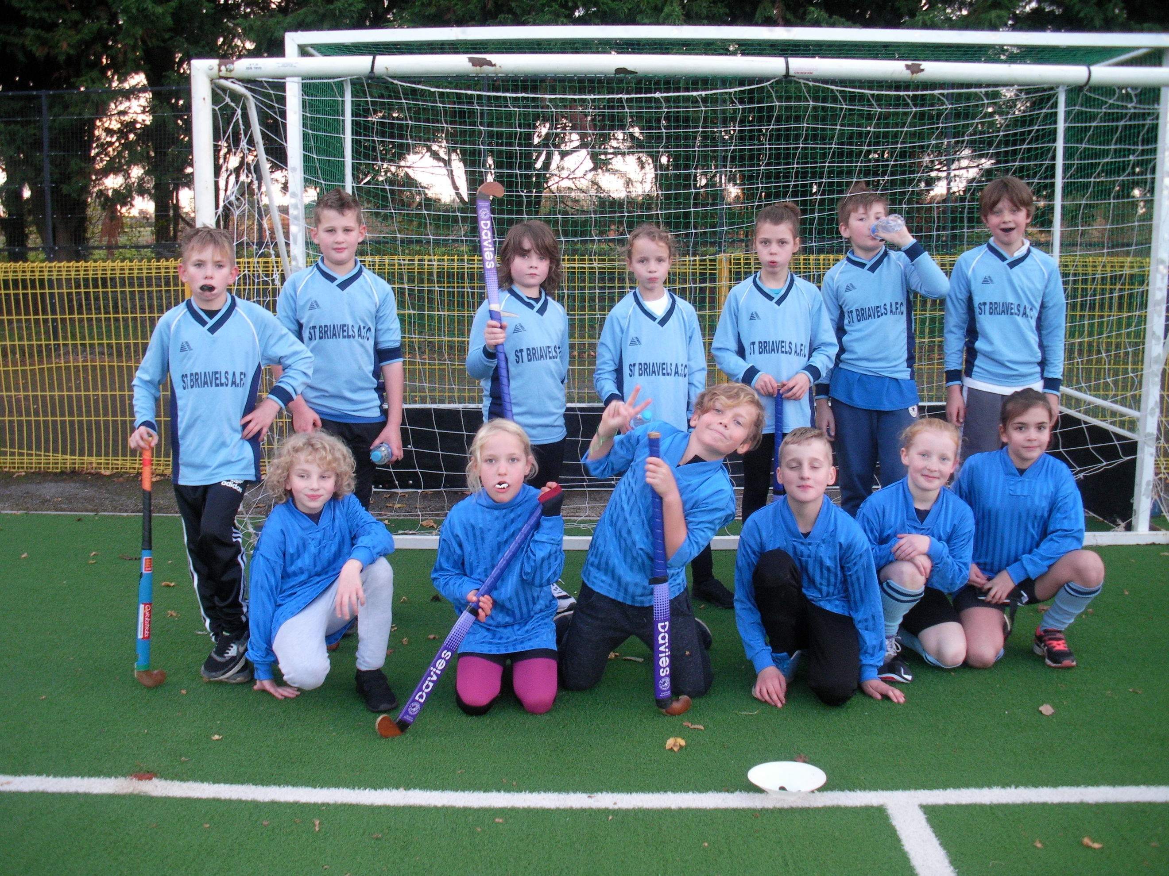  Supporting teachers across both schools to arrange School Games Hockey event thrugh SGO.

