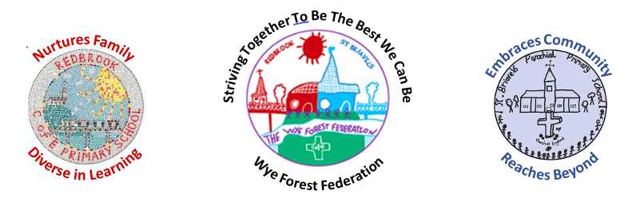

Early Years

Intent
At St Briavels Parochial Primary School we believe in providing a secure foundation for future learning and development for our children. Our EYFS curriculum allows children to develop interpersonal skills, build resilience and become creative thinkers. We aim to provide a progressive, challenging and rich educational environment that enables each individual to thrive! Reception and Nursery staff work closely with each other to ensure continuity and consistency between the foundation stage. Our Vision statement ‘Striving Together To Be The Best We Can Be’ is at the heart of everything we do.

Learning in Early Years is Values-based and built around our bespoke ‘drivers’. Our School Values; Respect, Resilience, Courage and Compassion and the ‘key drivers’ Diversity, Active, Independence and belonging shape how we behave, what we say, how we build relationships and how we learn. They are incorporated in every aspect of life at St Briavels School and Early Years. Every child is recognised as a unique individual. We celebrate and welcome the differences within our school community.
Implementation
The EYFS curriculum is designed to develop the characteristics of effective learning.
A progressive long term plan is in place meeting the needs of our children based around ‘core texts’ and a ‘big question’ each term. Some areas of learning benefit from skills progression documents to support our knowledge of child development and progression of key skills. Each term a WOW experience, trip and a cookery challenge is planned for, allowing children to achieve key skills. Parents play a huge part in our implementation, providing us with dialogue of their child’s interests and stages of development at home.
Community involvement is an essential part of our curriculum as we celebrate local traditions and learning new skills to enable the children to take an active role in events throughout the year, supporting our driver of ‘belonging’.

The EYFS framework includes 7 areas of learning and development that are equally important and inter-connected. However, 3 areas known as the prime areas are seen as particularly important for igniting curiosity and enthusiasm for learning, and for building children’s capacity to learn. Our EYFS Curriculum ensures that all children make good progress from their starting points because staff recognise what needs to be adapted or supported to enable children to learn a new skill or knowledge, promoting independence.
A number of key resources are used to support the development of our curriculum including Development Matters, Birth to Five Matters, White Rose Maths and Read Write Inc. Phonics (Ruth Miskin)

The children’s own interests are used by the adults to engage the children in higher level thinking and deeper learning. A balance of adult led and child initiated learning is valued and encouraged. Each area of learning and development is implemented through planned, purposeful play, and through a mix of adult- led and child initiated activities. At St Briavels Primary school and Early Years we believe that the whole curriculum can be covered in a well-planned outdoor environment. Our Bike Fridays and Forest School sessions support the ‘driver’ of being active. The children have the right to the outdoor environment all the year round and access to the area is available daily with adult supervision and interaction.
Parents are valued as first educators and every effort is made to inform them of the EYFS curriculum whilst providing them with the tools to continue in learning at home. Parents are encouraged to share their child’s achievements through ‘WOW’ moments and these are celebrated within school. Each week we have focus children where parental contribution is key to observing and planning children’s next steps. Strategies to include and inform parents include ‘Stay and Play’ sessions, phonics workshops, reading records, WOW moments and class pages on the website.

Impact
By the time children leave reception the curriculum ensures children are ready for their next stage as independent, resilient, active learners, ready for year 1. Children are prepared to continue on their early reading journey and will leave reception secure in set 1 and 2 phonic sounds. They will demonstrate their secure knowledge of numbers 1-20 and demonstrate understanding of writing simple sentences. In reading, children will begin to read confidently, understanding what they have read. Children will leave as motivated, independent leaners that have a sense of awe and wonder about the world around them.
The successful approach at The Wye Forest Federation results in a fun, engaging, high quality early education that provides children with the foundations to build upon for the National Curriculum.

